Extra Practice 3 – Master 4.27
Lesson 3: Exploring Rectangles with Equal Perimeters
1. a)
b)
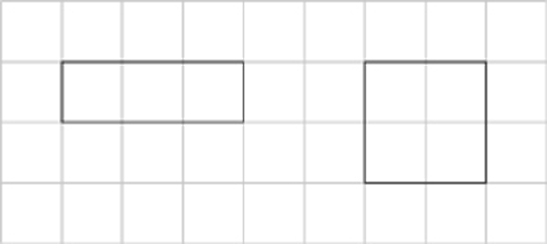
c)
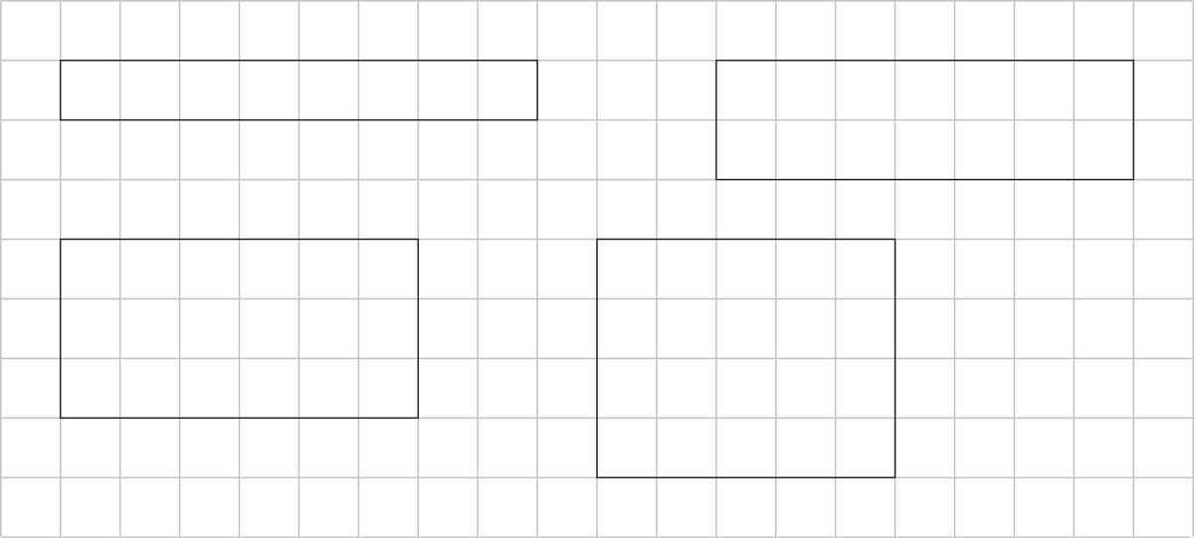

2. a)
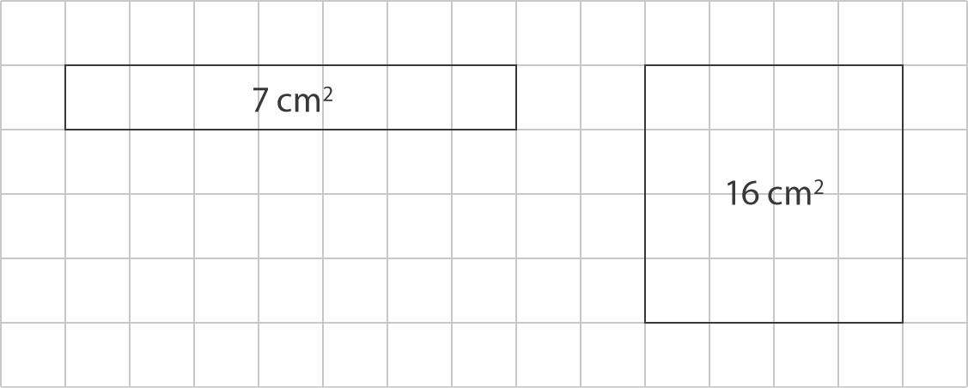

b)
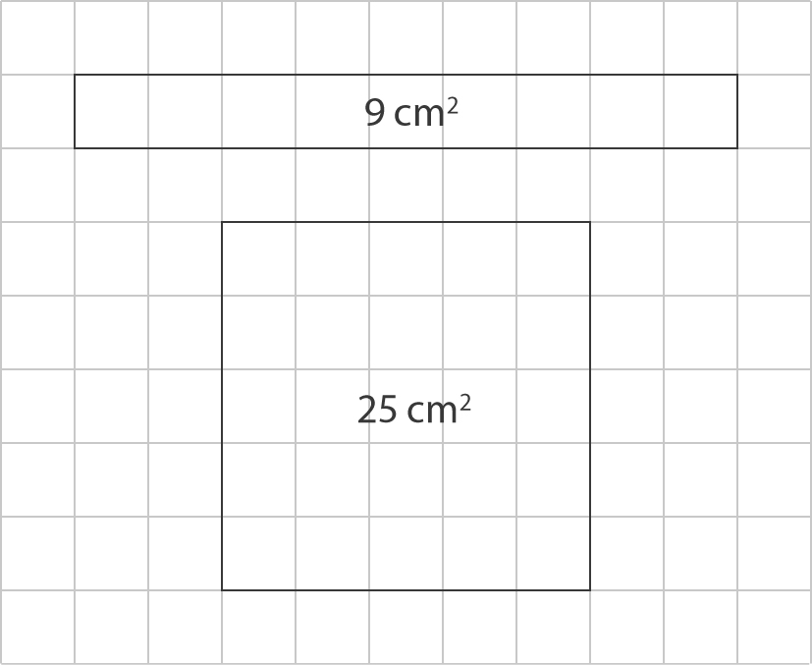
3. Student drawings should be rectangles with the following dimensions:
a) 8 cm × 4 cm
b) 9 cm × 2 cm
c) 7 cm × 4 cm
4. a) 1 m × 23 m, 2 m × 22 m, 3 m × 21 m,
4 m × 20 m, 5 m × 19 m, 6 m × 18 m,
7 m × 17 m, 8 m × 16 m, 9 m × 15 m,
10 m × 14 m, 11 m × 13 m, 12 m × 12 m
b) least area: 1 m × 23 m
greatest area: 12 m × 12 m

5. a) Student drawings should show a
12 cm × 8 cm rectangle drawn on
1-cm grid paper.
b) perimeter: 40 cm, area: 96 cm²
6. a) For example: student drawings could show a 10 cm × 10 cm square.
b) For example: student drawings could show a 6 cm × 14 cm rectangle.

