Extra Practice 1 – Master 8.17
1. The shape and orientation of the trapezoid may vary.
a) The image faces the same way as the shape. The image is to the right of and below the shape.
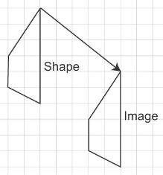
b) The image faces the same way as the shape. The image is to the right of and above the shape.
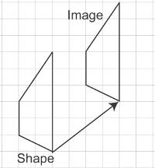
c) The image faces the same way as the shape. The image is to the left of and below the shape.
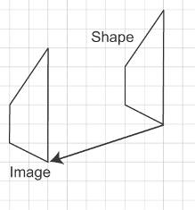
d) The image faces the same way as the shape. The image is to the left of and above the shape.
