Labour and Delivery
Stage 1
When contractions gradually open up the neck of your uterus (cervix). The first stage of labour consists of early/initial labour, active labour and the transitional phase.
- Initial Phase
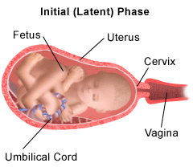
During early labour, your cervix starts to open and widen. It'll go from being closed to about 3cm or 4cm dilated. As a rough guide, early contractions are more than five minutes apart and short, perhaps only 30 or 40 seconds long (McCormick 2009).

- Active Phase
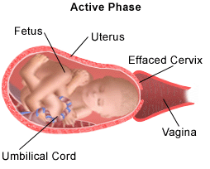
Your body has reached 4 cm. Contractions become stronger and closer together. You probably won’t be able to talk through these contractions. You may have to stop and breathe through them. Relaxation techniques will help you to keep calm and control your breathing.
Contractions may come as often as every three to four minutes and last 60 to 90 seconds. They'll feel very intense. Contractions in the active phase open your cervix more rapidly, but it may still be many hours before your cervix is fully dilated.
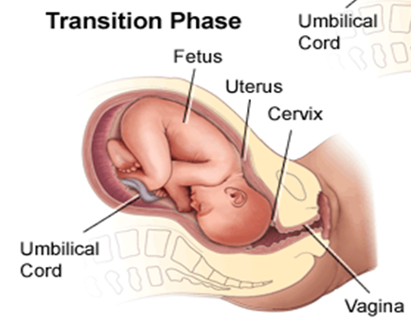
- Transition Phase

It often starts when your cervix is about 8cm dilated. It ends when your cervix is fully dilated (10 cm), or when you get the urge to push.
You may have less frequent, but much stronger and longer lasting contractions (Downe 2009). It's common for your water to break just before or during transition.
Stage 2
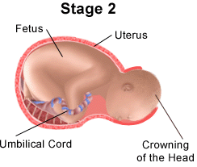
This is the stage of labour when you push your baby down your vagina (the birth canal) and, at long last, you meet him or her for the first time.
You'll feel pressure and with each contraction you may get two or three strong urges to push.
If you've had a baby before, the second stage may only take five or 10 minutes. If this is your first baby, it may take several hours.
When the widest part of your baby’s head is visible, your baby is crowning. Baby’s face, shoulders and body will emerge.

Stage 3
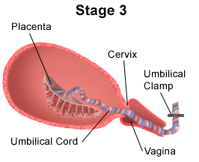
Once your baby is born, the third stage begins. Contractions, weaker this time, will start up again. These will make the placenta gradually peel away from the wall of your uterus. You may get the urge to push again. The placenta, will drop to the bottom of your uterus and then will pass through your vagina (McDonald 2009).
The “after birth”.

