Health Presentation Rubric

Name(s) : ______________________________, _________________________________ Date : ___________________________________
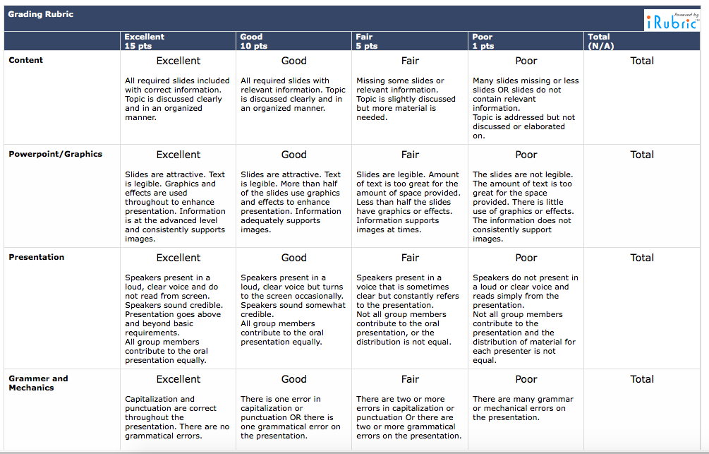
Total : ___________________

